|  |  |  |  |  |  |  |  |  |  |  |  |  |  |  |  |  |  |  |
| --- | --- | --- | --- | --- | --- | --- | --- | --- | --- | --- | --- | --- | --- | --- | --- | --- | --- | --- |
| **2023** | Victorian Certificate of Education  System Engineering Assessment Sheet  School-assessed Task | | | | | | | | STUDENT NAME | | | | | | | | | |
| This assessment sheet will assist teachers to determine their score for each student. Teachers need to make judgments on the student’s performance for each criterion. Teachers will be required to choose one number from 0–10 to indicate how the student performed on each criterion with comments, as appropriate.  Teachers then add the subtotals to determine the total score. | | | | | | | | | student number |  |  |  |  |  |  |  |  |  |
| assessing school number | | | | |  |  |  |  |  |
|  | | | | | | | | |  | | | | | | | | | |
| **Criteria for the award of grades** | | | Not Shown (0) | Very Low (1–2) | Low  (3–4) | Med  (5–6) | High  (7–8) | Very High (9–10) | **Performance on Criteria: Teacher’s Comments**  You may wish to comment on aspects of the student’s work that led to your assessment. | | | | | | | | | |
| The extent to which the record of investigation design, planning and production  demonstrate skill in: | | |  |  |  |  |  |  |
| 1 investigation of a problem/situation/opportunity/need, and develop a design brief  for an integrated controlled system including evaluation criteria | | |  |  |  |  |  |  |
| 2 researching, devising, designing and modelling design options | | |  |  |  |  |  |  |
| 3 planning the creation of the system | | |  |  |  |  |  |  |
| The extent to which the production work and accompanying documentation,  including the record of progress and modifications, demonstrate skill in: | | |  |  |  |  |  |  |
| 4 use of tools, equipment and machines to make the system | | |  |  |  |  |  |  |
| 5 realisation of an integrated controlled system | | |  |  |  |  |  |  |
| The extent to which the diagnostic testing, report and performance data demonstrate: | | |  |  |  |  |  |  |
| 6 use of diagnostic test procedures and interpreting test data | | |  |  |  |  |  |  |
| The extent to which the production folio, and teacher observation of student progress  throughout the Systems Engineering Process, demonstrate skill in: | | |  |  |  |  |  |  |
| 7 project management to realise the preferred option | | |  |  |  |  |  |  |
| The extent to which the evaluation report demonstrates skill in: | | |  |  |  |  |  |  |  | | | | | | | | | |
| 8 evaluating the use of the Systems Engineering Process including finished integrated  controlled system. | | |  |  |  |  |  |  |
| If a student does not submit the School-assessed Task  at all, N/A should be entered in the total score box. | | **SUBTOTALS** |  |  |  |  |  |  |  | | | | | | | | | |

**2024 YEAR 12 SYSTEMS ENGINEERING**

**SEMESTER 1**

**TERM 1**

SAC 1 CLEAN ENERGIES coal/solar/hyro/wind 10%

**TERM 2**

PROJECT AND FOLIO First part due term 2 criteria 1-3 18%

**SEMESTER 2**

**TERM 3**

SAC 2 NEW AND EMERGING TECHNOLOGIES 10%

PROJECT AND FOLIO Criteria 4-8 and Project due last week of Term 3 32%

**TERM 4**

EXAM 30%

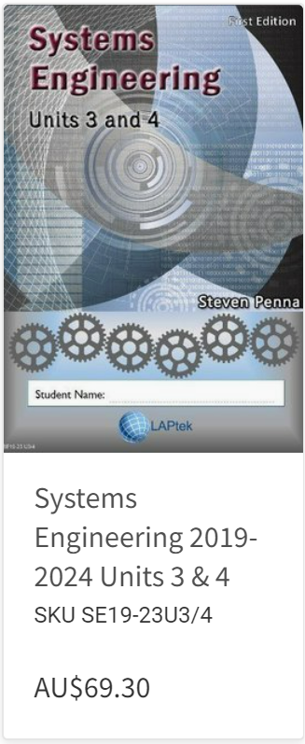

Textbook https://www.laptek.com.au/store/Systems-Engineering-2019-2024-c29202001

**PROJECT IDEAS**

**TOP DESIGNS**- The 12 best project from each year Compass/Resources/ECP/ECP SYSTEMS

<https://www.instructables.com/>

Your project must be one **integrated** **controlled** **system** (closed or open loop) incorporating both **Mechanical** and **Electrical**

Complies with all safety regulations and Australian standards

The more processes you use the better

* CAD design
* 3D printing diff print lmaterials
* Laser cutting
* Arduino or raspberry pi coding
* Circuit board construction
* Vacuum forming
* CNC milling

Create a word doc and start dropping all your **RESEARCH** links with descriptions into it now, this will help with criteria 2.

ECP timeline

Unit outline

Project ideas

SAT (project) Marking criteria 1-8

Gannt chart

Folio examples.

Ideally by the end of ECP you should have decided on a project. If you are purchasing parts and components for you project can you run this by me first please. Purchasing items can take weeks or even months to arrive so it is important that this is done early in the year.